UBC Urgent Care COVID-19 Clinic Protocol

Appointment Booking Flow

Patients experiencing pain or other discomfort are to contact their assigned student. The student is to review the situation to help determine the level of care required and to screen the patient for acute respiratory infection risk.

- Student Initial Assessment of Required Care Over Phone/Email

The student is to determine the nature of the problem and its characteristics. The type of care required is to be aligned with the definitions provided by the College of Dental Surgeons of BC (below).

College of Dental Surgeons of BC (CDSBC) Announcement
https://www.cdsbc.org/about-cdsbc/news/covid-19/covid-19-for-registrants

The College of Dental Surgeons of BC (CDSBC) has strongly recommended that provision of all non-essential (elective) care to be suspended for now. To help practitioners better interpret this recommendation, the following definitions are of emergent, essential (urgent) and non-essential care.
EMERGENT CARE: Emergency dental care is defined as potentially life-threatening conditions requiring immediate management or treatment to stop ongoing tissue bleeding, alleviate severe pain or infection and include:
Cellulitis as a result of an uncontrolled infection compromising the airway
Severe uncontrolled hemorrhage (bleeding)
Trauma to the orofacial complex especially to facial bones that potentially compromise the patient’s airway
Uncontrolled severe pain
Uncontrolled infection

ESSENTIAL (URGENT) CARE: Essential care is separate from emergency care and focuses on the management and treatment of conditions that require immediate attention to relieve pain and/or risk of infection. These should be treated as minimally invasively as possible. These conditions would include (but not limited to):
Pericoronitis or third molar pain
Post-operative osteitis (dry socket dressing changes)
Abscess with localized pain and swelling
Treatment required before critical medical procedures can be provided
Dental trauma involving avulsion or luxation of a tooth
Tooth fracture resulting in pain or causing soft tissue trauma

NON-ESSENTIAL (ELECTIVE) CARE: Non-essential care is routine or non-urgent procedures and would include (but not limited to):
Recall examinations including routine radiographs
Routine debridement and preventive therapies
Orthodontic procedures other than those to address acute issues (e.g. pain, infection, trauma)
Restorative dentistry (including treatment of asymptomatic carious lesions)
Aesthetic dental procedures.

- Patient Screening for Acute Respiratory Illness

The patient must be screened for acute respiratory illness, including COVID-19: presence of fever, cough, difficulty breathing AND any of the following:
  - Returned from travel to any country outside of Canada in the last 14 days; OR
  - Close contact with a confirmed or probably case of COVID-19; OR
  - Close contact with a person with acute respiratory illness who has returned from travel to an impacted area

- Student is to then contact the designated faculty member to discuss the case and get orientation

- The faculty member decides if the patient needs an appointment in the clinic. Otherwise, the faculty member will provide the patient with prescription and/or instructions

- If an appointment is required, the Front Desk to be advised via email dentalclinic@dentistry.ubc.ca the patient’s information, type of appointment required and the amount of time necessary.

Reception Duties

- Check patient’s risk for acute respiratory infection, prior to scheduling appointment.
Identify patients with suspected case of COVID-19.
- Fever >37.3 degrees C
- Coughs
- Breathing difficulties
- Muscle pains
- Headaches in the last 14 days

This protocol is for patients with low-risk for acute respiratory infection

The day before the appointment:
- Call the patient and ask them if:
  - they have had symptoms,
  - they have been in contact with infected people or with these symptoms for the past two weeks
  - they attended events in crowded places

On the day of appointment:
- At the time of patient check-in, all patients are asked about the presence of symptoms.
- Make sure patients observe social distancing in the waiting room.
- Ensure hand sanitizer is available at the front desk
- If a patient is suspected or confirmed to have COVID-19, take the following actions:
  - Give the patient a mask to cover his or her mouth
  - Send the patient home if not acutely sick
  - Refer the patient to UBC Urgent Care Hospital if acutely sick (e.g., trouble breathing)
  - If treatment is urgently needed, refer to an appropriate facility
- Call 9-1-1 in the event of medical emergencies
- Next the patient is directed to the temperature-taking station at the Reception area and is instructed as below

HOW TO USE A DISPOSABLE THERMOMETER
  - Sanitize your hands
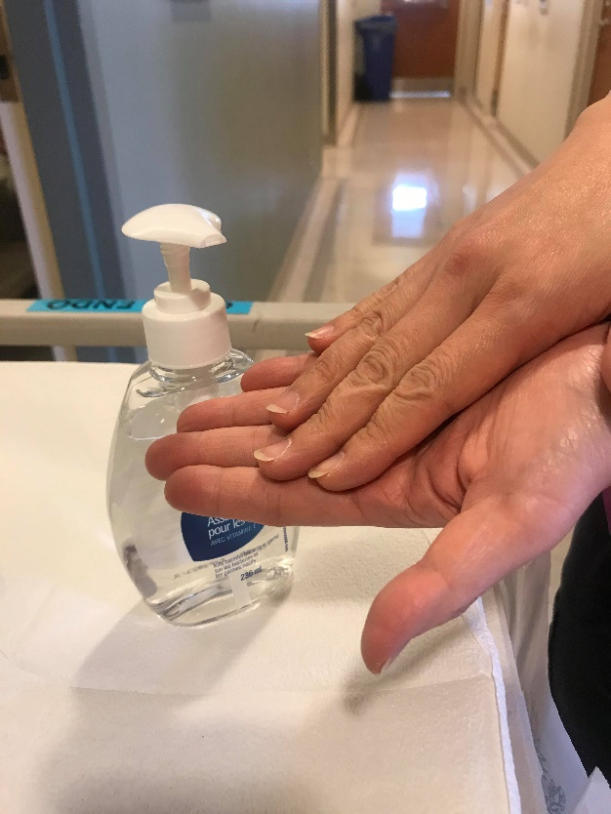
  - Open Package and Hold Thermometer by the Handle
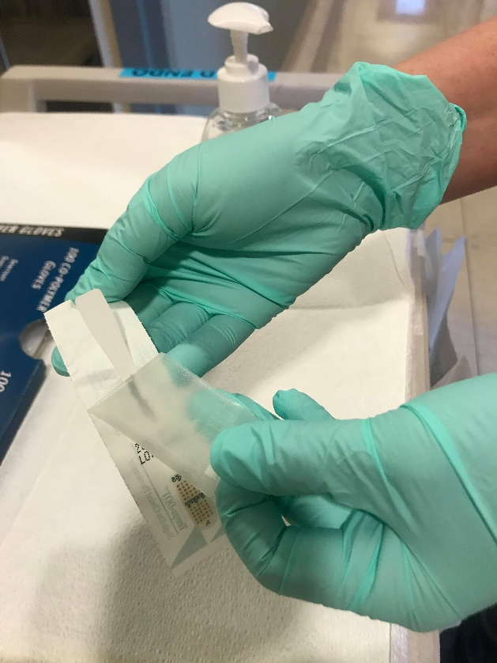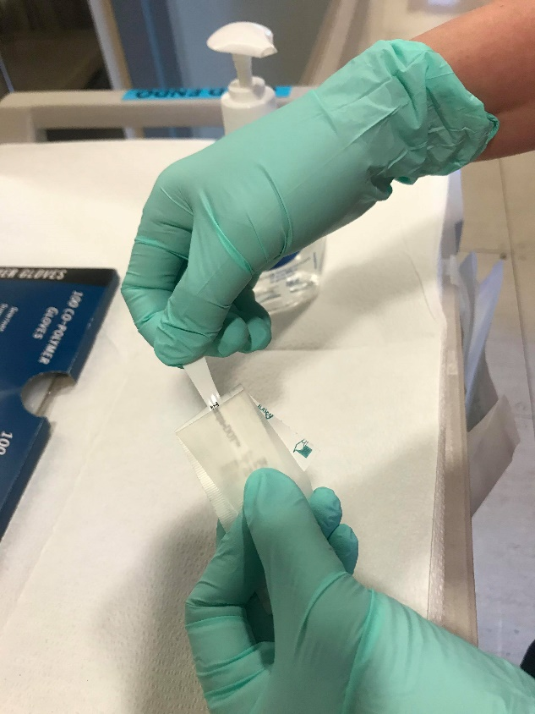

  - Insert Thermometer Under the Tongue As Far Back as Possible and Close the Mouth
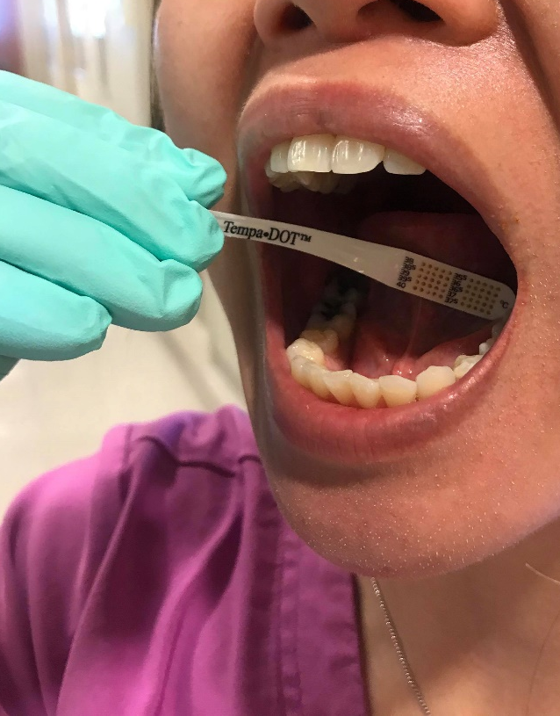
  - Wait 60 seconds
  - Remove Thermometer and Wait 10 Seconds
  - Read and Record Temperature – The Last Dot indicates The Correct Temperature -
For example, this one reads 37 degrees C.
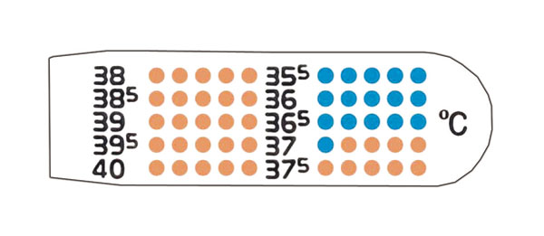
Report your Temperature to the Receptionist
7. Discard/Throw out Thermometer in Garbage Provided and Sanitize Hands

Clinic CDA Duties
At the clinic:
Six enclosed operatories have been prepared for Emergent and Urgent cases. Rooms will be locked down for 2 hours after they are used.
Room preparation:
  - Clean and disinfect the room and equipment according to the UBC Infection Prevention & Control protocol.
  - Use products with EPA-approved emerging viral pathogens claims.
  - Clean, disinfect, or discard the surface, supplies, or equipment located within 6 feet of patients.
  - Use large overgloves to cover the two wall fixtures.
  - Use x-ray barrier bag to cover the two monitors, the keyboard, the phone and x-ray head.
  - Use dental chair barriers to cover operator chair, patient chair, kidney table and microscope.
  - **Patients should NOT be touching door handles. Staff should be opening all doors for patients.
Adhere to Standard and Transmission-Based Precautions
- Hand Hygiene
  - HCP should perform hand hygiene before and after all patient contact, contact with potentially infectious material, and before putting on and after removing PPE, including gloves. Hand hygiene after removing PPE is particularly important to remove any pathogens that might have been transferred to bare hands during the removal process.
  - HCP should perform hand hygiene by using Alcohol-Based Hand Rub (ABHR) with 60-95% alcohol or washing hands with soap and water for at least 20 seconds. If hands are visibly soiled, use soap and water before returning to ABHR.
  - Healthcare facilities should ensure that hand hygiene supplies are readily available to all personnel in every care location.
Personal Protective Equipment
- Respirator or Facemask
  - Put on a facemask before entry into the patient room or care area.
  - N95 respirators or respirators that offer a higher level of protection should be used instead of a facemask when performing or present for an aerosol-generating procedure.
  - Disposable respirators and facemasks should be removed and discarded after exiting the patient’s room or care area and closing the door.
  - Perform hand hygiene after discarding the respirator or facemask.

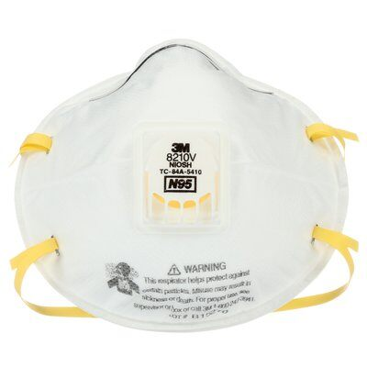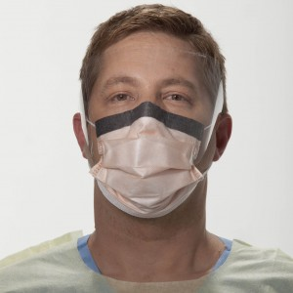
3M Particulate Respirator N95 Level 3 Procedure Mask with Visor
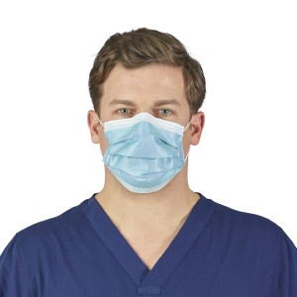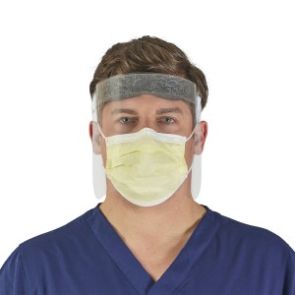
Level 3 Procedure Mask Halyard Face Shield

- Eye Protection
  - Put on eye protection (i.e., goggles or a disposable face shield that covers the front and sides of the face) upon entry to the patient room or care area. Personal eyeglasses and contact lenses are NOT considered adequate eye protection.
  - Remove eye protection before leaving the patient room or care area.
  - Reusable eye protection (e.g., goggles) must be cleaned and disinfected according to manufacturer’s reprocessing instructions prior to re-use. Disposable eye protection should be discarded after use.

- Gloves
  - Put on clean, non-sterile gloves upon entry into the patient room or care area.
    - Change gloves if they become torn or heavily contaminated.
  - Remove and discard gloves when leaving the patient room or care area, and immediately perform hand hygiene.
- Gowns
  - Put on a clean isolation gown upon entry into the patient room or area. Change the gown if it becomes soiled. Remove and discard the gown in a dedicated container for waste or linen before leaving the patient room or care area. Disposable gowns should be discarded after use.
  - Wear disposable doctor cap
5 Steps to Don PPE
http://www.bccdc.ca/Health-Professionals-Site/Documents/COVID19_MOH_BCCDC_Donning.pdf
9 Steps to Doff PPE
http://www.bccdc.ca/Health-Professionals-Site/Documents/COVID19_MOH_BCCDC_Doffing.pdf

Preparaton of Operatories
Disinfect and prepare enclosed operatories. See photos for examples of closed operatory set-up.
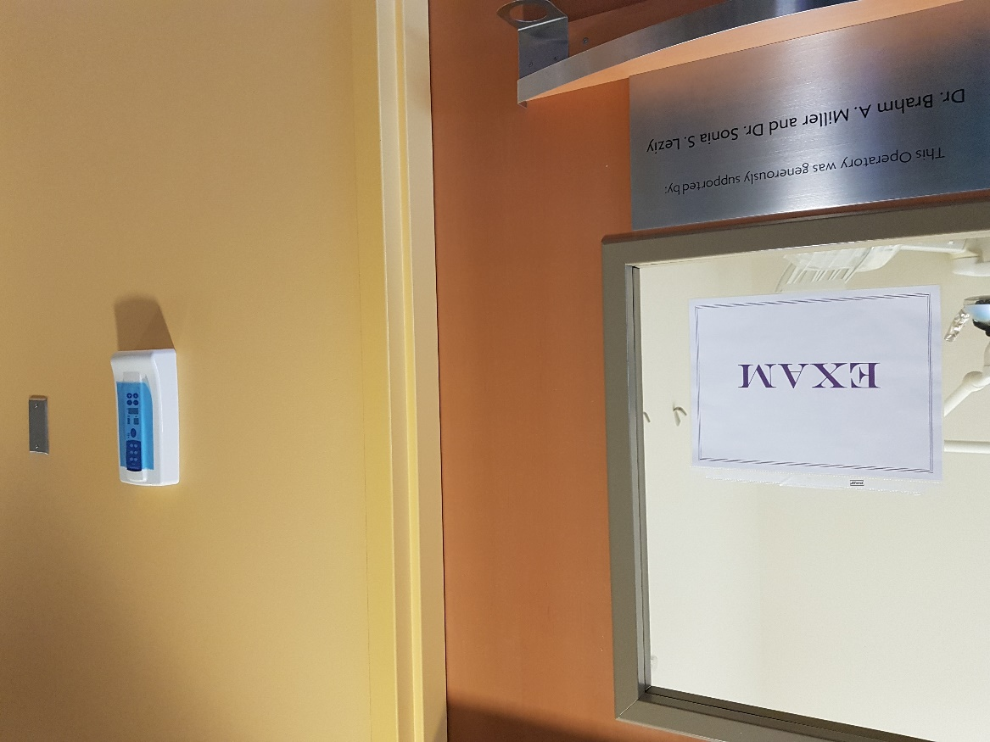
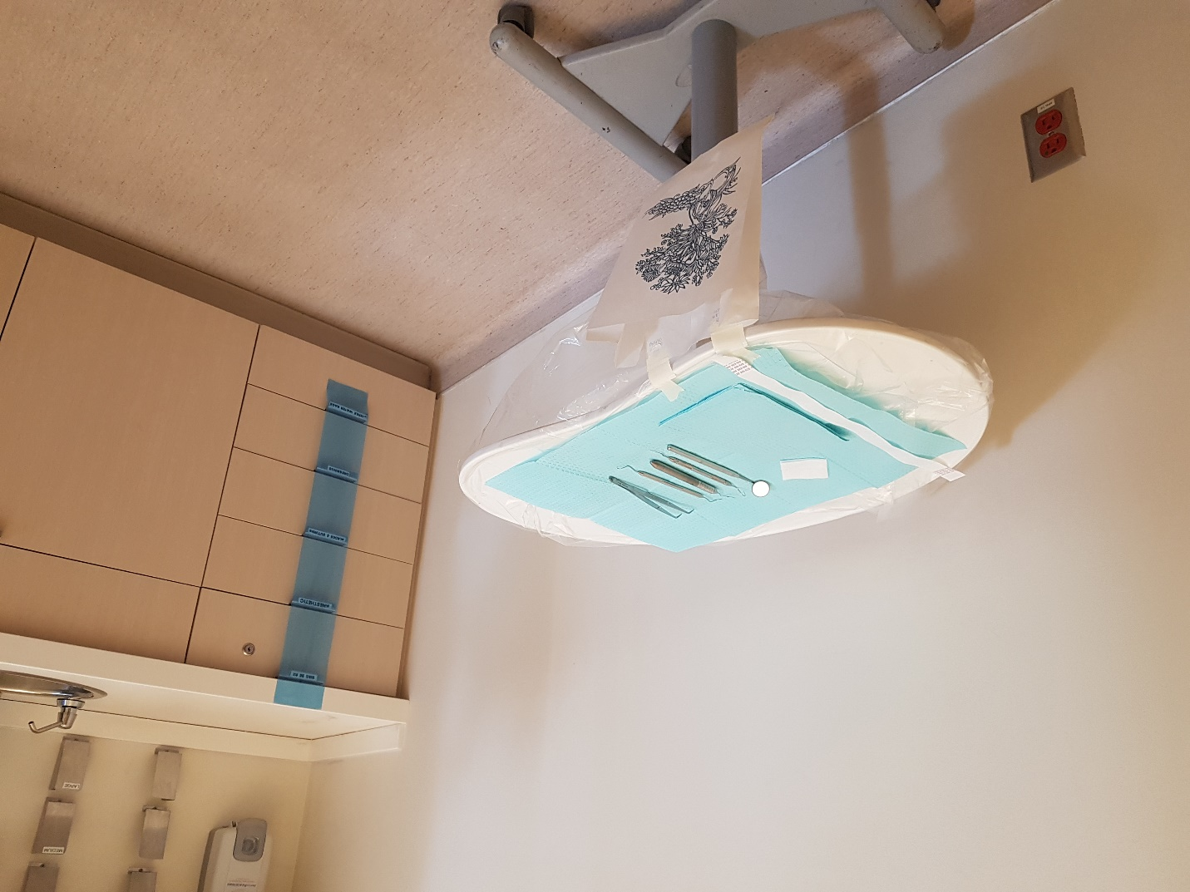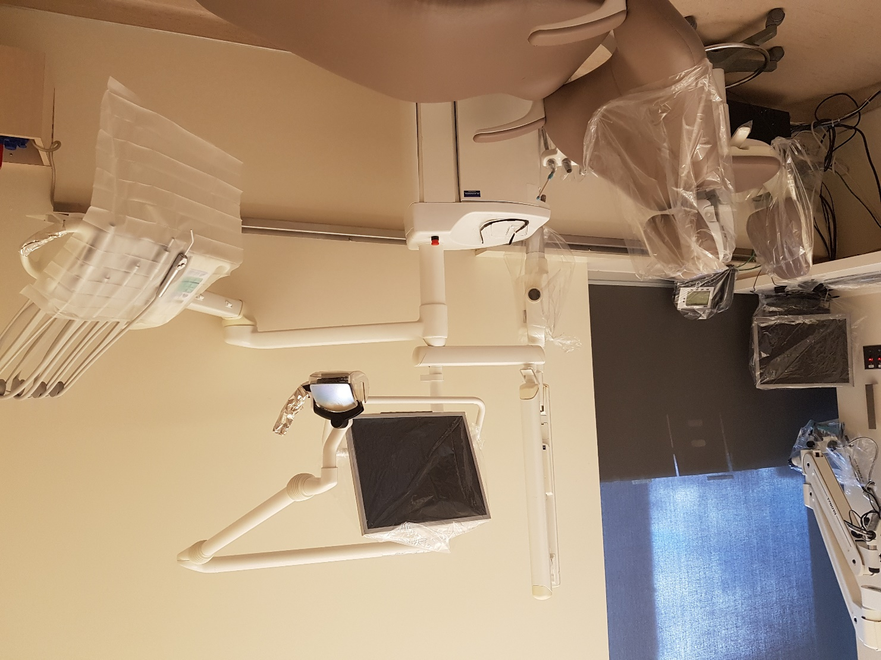
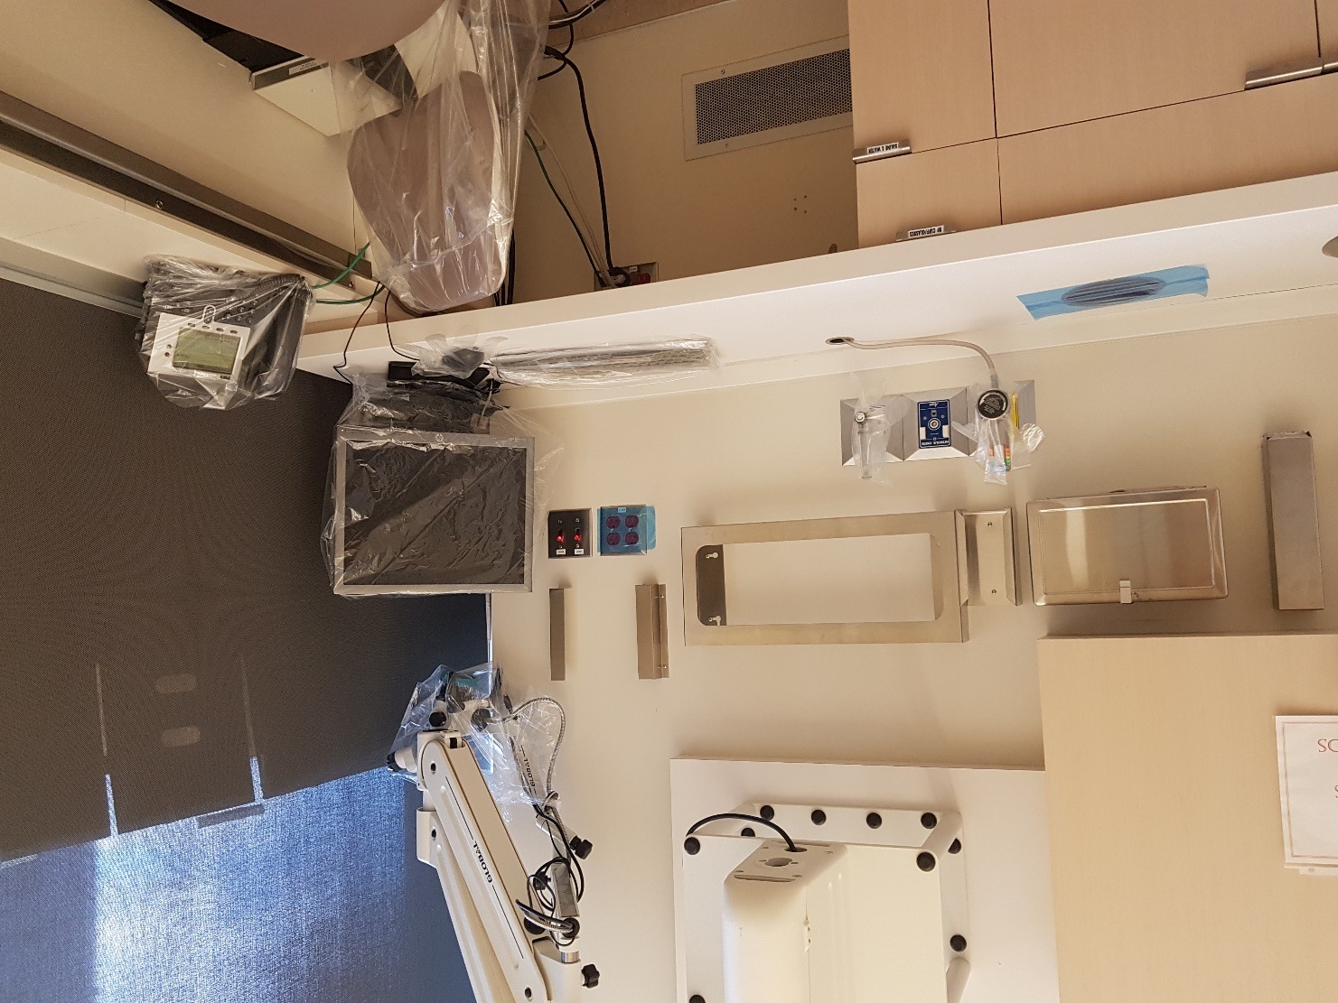
Use large overgloves to cover and the two wall fixtures.
Use x-ray barrier bag to cover the two monitors, the keyboard, the phone and x-ray head.
Use dental chair barriers to cover operator chair, patient chair, kidney table and microscope.
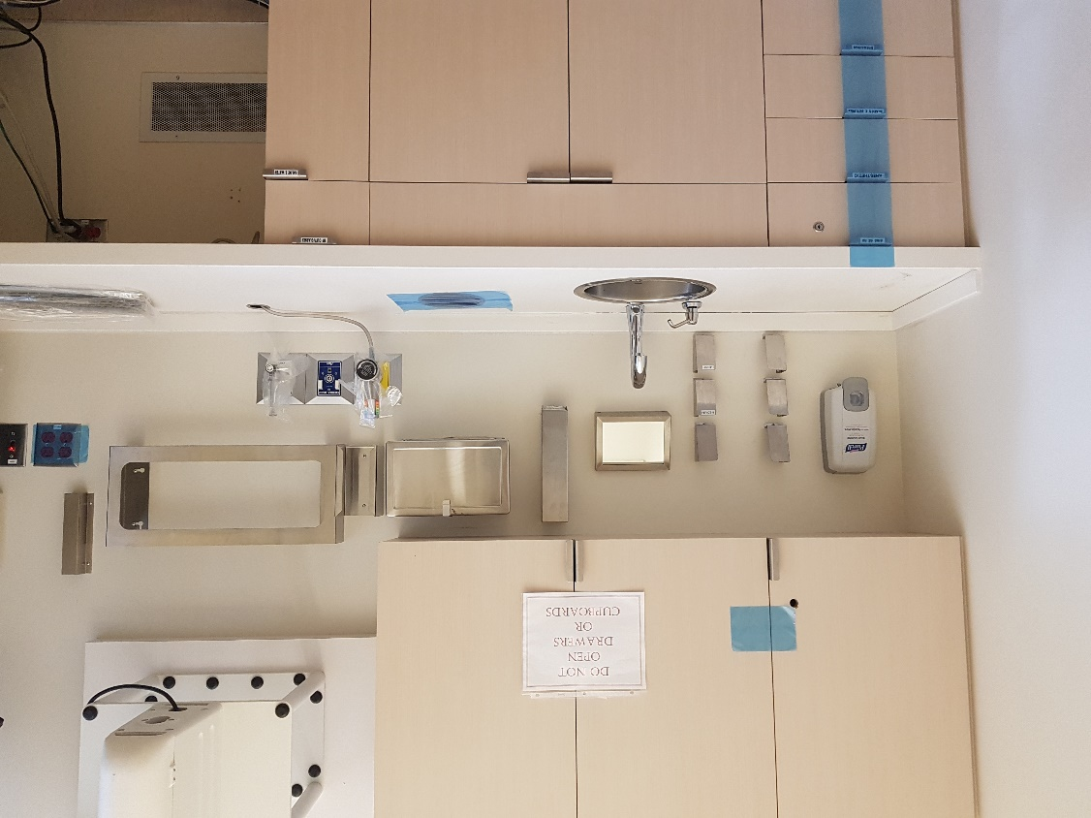
- Prepare and stock: One for each specialty, One for infection control, One for PPE

  - Infection Control
    - Chair covers
    - X-ray bags
    - Foil
    - Steri-drapes
    - Patient packs
    - Blue barrier film rolls
    - Large overgloves
    - Paper bags
    - Optim wipes
    - Cavicide spray
    - Masking tape
    - Scissors
    - Preprocedural rinse
    - Tempodot or digital thermometer
    - Patient drapes
    - Disposable bib chains
    - Safety glasses

  - PPE
    - White gowns (Impervious gowns) – only 85 left at inventory
    - Disposable face shields – only 12 with Pedo and 25 at CSD at inventory
    - Nonlatex gloves – small, medium and large
    - Bouffant hair caps
    - Level 3 shield masks
    - Optim wipes
    - Chair Covers

  - General and Pros
    - Exam kit
    - Basket with prescription pads, pens, note paper
    - Basket with separate mirrors, explorers, cotton pliers, hand mirrors
    - Endo ice
    - Floss
    - Occlude
    - Vaseline
    - Mixing pads
    - 2x2s
    - Cotton tip applicator
    - Articulation paper and forceps
    - Tooth sleuth
    - Resto handpiece kits
    - Straight handpiece
    - Acrylic adjustment blocks
    - Resto bur blocks
    - Composite finish bur blocks
    - Removable appliance kit
    - 3 BP monitors
    - Clip board and paper

  - X-ray cart
    - Lead apron
    - PSPs Size 1 and 2s
    - RINNS – anterior, posterior and endo
    - Snap-A-Ray
    - Bite Wing Tabs

  - Oral Surgery and Periodontics
    - Surgical consent forms and postop forms
    - OS trays
    - Perio Abscess Tray
    - Electric handpiece
    - Surgical handpiece with coupler and burs/white hose barriers
    - Anesthetic syringe
    - Saline with metal cups
    - Monoject syringes
    - Blade handles + 15 blades
    - 3-0 gut suture
    - Surgical suction
    - Periosteal elevator
    - Surgical curette
    - Miscellaneous scalers
    - Root tip picks
    - Straight elevator
    - Potts
    - Cryers
    - Miscellaneous forceps
    - Bite blocks
    - Suction tubing
    - Scissors
    - Needle drivers
    - Dry socket paste
    - Paper mixing pad and spatula
    - Gelfoam
    - Surgicel
    - Bite blocks
    - Sterile 2x2 gauze
    - Paroex

  - Endodontics
    - Open and drain
    - Endo cassettes
    - Rubber dam
    - Resto HP kits
    - Titrator
    - EPT and tips
    - Apex locator and tips
    - Local anesthetic: 2% lidocaine 1:100, 000 epinephrine, 4% articaine 1:200, 000 epinephrine, 3% mepivacaine
    - Anesthetic needles: 27 gauge long, 30 gauge short
    - Topical anesthetic
    - Alcohol
    - Plastic cups – small and large
    - 6% sodium hypochlorite
    - 10 ml syringes
    - Endo irrigation needles
    - Paper points – fine, medium and coarse
    - Cotton pellets
    - Cotton rolls
    - 2 x 2 gauze
    - Endo bur blocks
    - Endo rings and sponges
    - Latex free rubber dam
    - Fuji IX kit and material
    - Photac kit and material
    - Calcium hydroxide syringe with navi tips
    - Cavit

- Prepare personal protection gear for Faculty providers.
  - Primary protection (standard protection for all staff in clinical settings) – Wear disposable working cap, disposable surgical mask, and working clothes, use protective goggles or face shield and disposable latex or nitrile gloves
  - Secondary protection (advanced protection for dental professions) – wearing disposable doctor cap, disposable surgical mask, protective goggles, face shield and working clothes with disposable isolation clothing or surgical clothes outside, and disposable latex gloves.

- Prepare preprocedural rinse
  - Chlorhexidine may NOT be effective in killing Covid-19 virus
  - Since CoVid 19 vulnerable to oxidation, preprocedural mouthrinse containing oxidative agents such as 1% hydrogen peroxide or 0.2% povidone is recommended
  - Per Faculty consult, best to avoid povidone iodine due to allergy risk
  - Colgate Peroxyl contains 1.5% hydrogen peroxide rinse
  - Patient instructions: Gargle and swish the mixture around in your mouth for 60 seconds (use a timer or count silently to 60). Spit the solution out after gargling. Don’t try to gargle the mixture for more than 90 seconds.
  - To mix own mouthwash: Start with a 3% concentration of hydrogen peroxide. This is the strength you’ll find in a brown bottle at most drug stores. Next, combine one part hydrogen peroxide with two parts water. Your final mix will have a concentration of 1% hydrogen peroxide. We have 3% hydrogen peroxide in the CSD-R shelves.

- Disinfection of Operatories, Management of instruments and Disposal of Medical Waste

Disposal of Medical Waste
The medical waste (including disposable protective equipment after use) should be transported to the temporary storage area of the clinic timely. The reusable instrument and items should be pretreated, cleaned, sterilized and properly stored. Double-layer medical waste package bags and “gooseneck” ligation should be used. The surface of the package bags should be marked and disposed according to the requirement for the management of medical waste.
A biohazard bag will be left inside treatment room to receive used PPE and other contaminated items for disposal including blood bottle.
BioHazard Waste: Disposal
1. Place red contaminated solid waste bag into a red bucket lined with a yellow bag. Seal the yellow bag with a twist and make sure all bag is in bucket
2. Place lid on bucket and hammer closed
3. Place red tag on the bucket and indicate Human Anatomical on the tag ( highest risk group)
Can place a blood bottle in the bucket with the contaminated waste and mark tag with Human Blood & Body Fluids
4. Take bucket down to Hazardous waste storage

Sharps Disposal
Suggested to place sharps in container as provided and wait until 75% full before disposing.
Lid may be closed without locking or covered with replaceable material in between use.

PROVIDER DUTIES
- Communication between operator and CDAs
- Radiographs
  - CCD available in the room
  - PSP available, use surgical protocol for scanning
  - Panoramic

Table 1 : Adapted from: World Health Organization. "Rational use of Personal Protective Equipment for Coronavirus Disease 2019 (COVID-19)." (February 27, 2020): 1-7
Non-COVID-19 patients
Patient room | Dentists | Aerosol-generating procedures (AGP) | N95 mask  Face shield  Eye protection  Gown  Gloves
 |  | Providing direct care (non-AGP) | Level 3 mask  Eye protection  Gown/lab coat  Gloves
 | Disinfecting treatment rooms | Entering the room | Level 3 mask  Eye protection  Gown  Gloves
 | Visitors | Entering the room | No PPE required
Other areas of patient transit (e.g., wards, corridors) | All staff | Any activity that does not involve contact with patients | No PPE required
Triage | Door greeter/ triage | Preliminary screening (vitals, hydrogen peroxide rinse) | Level 1 mask  Eye protection  Gown/lab coat  Scrubs  Gloves  Maintain spatial distance of at least 2 m.
 | Patient at triage presenting with COVID-19 symptoms or risk factors | Any | Provide level 1 mask.  If mask not tolerated, patient to hold tissue over mouth.  Direct patient to UBC Urgent Care  Maintain spatial distance of at least 2 m.
 | Patients without respiratory symptoms | Any | No PPE required

Acknowledgments
This protocol was adapted from the Dalhousie Faculty of Dentistry: COVID-19 Emergency Clinic Action Plan that was generous provided by Dean Benjamin Davies. The UBC Faculty of Dentistry Clinic Staff worked diligently organizing the text, providing the photos and re-working protocols. Thanks to Dr. Shimae Soheilipour for her revisions and input.

MOCK UP GUIDE for CLINIC TEAM For URGENT CARE COVID-19 CLINIC
(For review by all and further development)

Clinic is treating Low Risk Patients.
RECEPTIONIST
- The Front Desk to be advised via email dentalclinic@dentistry.ubc.ca the patient’s information, type of appointment required and the amount of time necessary.
- Patient is scheduled for an appointment.
- Receptionist phones patient the day before the appointment to ask:
- they have had symptoms,
- they have been in contact with infected people or with these symptoms for the past two weeks
- they attended events in crowded places
- Confirms the appointment if no the above.
- Advises patient to phone reception when waiting outside clinic entrance on day of the appointment.
- Asks patient if they can bring payment and if possible, credit card for tap payment.
- Advise CDA4 of appointment specifics (for operatory preparation and armamentarium planning).
- Scan consent form into patient’s chart upon receipt from CDA Greeter/Triage.
Non-COVID-19 patients
Patient room | Dentists | Aerosol-generating procedures (AGP) | N95 mask  Face shield  Eye protection  Gown  Gloves
 |  | Providing direct care (non-AGP) | Level 3 mask  Eye protection  Gown/lab coat  Gloves
 | Disinfecting treatment rooms | Entering the room | Level 3 mask  Eye protection  Gown  Gloves
 | Visitors | Entering the room | No PPE required
Other areas of patient transit (e.g., wards, corridors) | All staff | Any activity that does not involve contact with patients | No PPE required
Triage | Door greeter/ triage | Preliminary screening (vitals, hydrogen peroxide rinse) | Level 1 mask  Eye protection  Gown/lab coat  Scrubs  Gloves  Maintain spatial distance of at least 2 m.
 | Patient at triage presenting with COVID-19 symptoms or risk factors | Any | Provide level 1 mask.  If mask not tolerated, patient to hold tissue over mouth.  Direct patient to UBC Urgent Care  Maintain spatial distance of at least 2 m.
 | Patients without respiratory symptoms | Any | No PPE required

CDA TEAM
- Print and post sign on operatory with procedure and operators especially if multiple operators on the same day
- Duties are assigned to each team member. Specific notes for CDA Greeter/Triage below.
- Inform tech if assistance needed with clinic equipment.
- Disinfect and replenish temperature taking station/cart after each use.
- Prepare operatory and armanataria as per Faculty instructions.
- Follow instructions in protocol for set-up of rooms (see photos and written instructions above)
- Include biohazard bag inside the operatory.
- Provide guidance to Dentist and Students when donning and doffing PPE. (See posters on pages 19-20)
  - Best to show posters provided in clinic. Follow order for donning and doffing as recommended.
  - Ensure that Dentist Doff ALL PPE INSIDE treatment room (cannot leave the room until all PPE Doffed) with required hand hygiene
- No PPE required if work involved does not have contact with patients unless disinfecting treatment rooms
- Circulating duties
  - Process PSPs as requested by Faculty
  - Provide Instruments and equipment needed by Faculty
  - Determines if 2nd room is needed and makes preparations as needed
- CDA PPE when disinfecting treatment rooms:
  - Level 3 mask
  - Eye protection (Personal eyeglasses do not constitute adequate protection)
  - Gown
  - Gloves
- Observe and record time treatment is completed and wait 2 hours before any cleaning and disinfecting operatory and instruments
- Procedure for disinfecting rooms
  - Record time dental treatment is completed
  - Close the door of the operatory and put a do not enter sign (for disinfection)
  - Disinfect the room after 2 hours has past
  - Remove and discard all disposable items, barriers and place into biohazard bag
  - Spray all surfaces and instruments used with Optim and leave disinfectant for time specified by manufacturer
  - Wipe down semi critical surfaces with Optim wipes
  - Repeat
  - Transport used instruments to CSD-R, may cover instruments
  - Collect all medical waste into biohazard bag
  - Disinfect all suction lines
  - Flush waterlines if handpieces used
- Dispose of medical waste
- Prepare room for next appointment as needed
- Replenish supplies in carts as needed
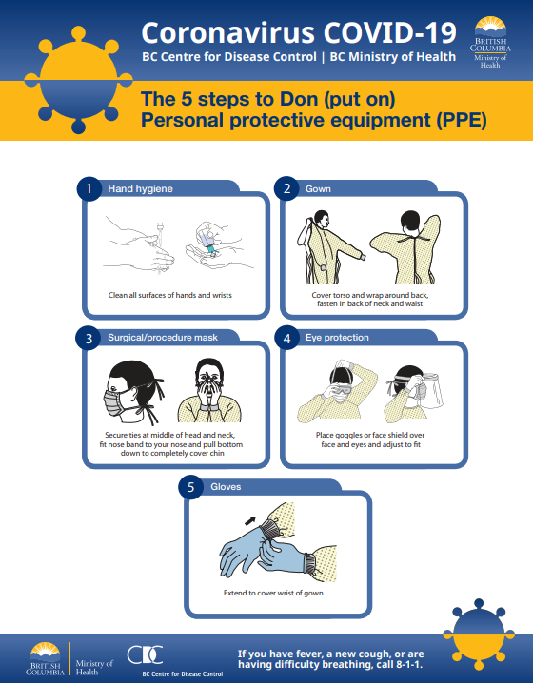
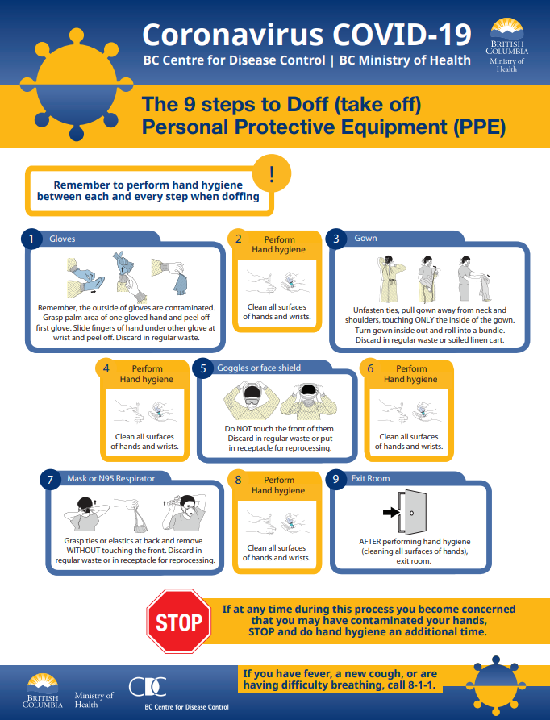

CDA GREETER/TRIAGE
- Dons PPE before greeting patient
- Level 1 mask
- Eye protection
- Gown/lab coat
- Scrubs
- Gloves
- Maintain spatial distance of at least 2 meters
- Wait for receptionist to advise of patient’s arrival.
- Opens the door for the patient at clinic entrance.
- Directs patient to temperature taking station and instructs patient to self-measure temperature.
  - Patient Is asked to sanitize hands, then to open tempodot, wear overgloves and self-measure temperature (show visual instructions in cart)
  - CDA Greeter/Triage sets 1 minute timer
  - CDA Greeter/Triage mentally records patient’s temperature
  - CDA Greeter/Triage asks patient to discard Tempodot in paper bag
- If temperature <37.3, presents patient with consent form to sign.
  - Consent form is placed in protective sleeve, is reviewed by CDA, disinfected and returned to receptionist for scanning
  - Ensure patient understands consent form. Patient to contact our clinic in the event they test + COVID-19 at a later date.
- CDA Greeter/Triage asks patient to use the washroom before the appointment
- CDA Greeter/Triage escorts patient into treatment area.
- When Faculty Provider opts for use of PSP for radiographs, CDA Greeter/Triage waits for PSP and receives it in a cup after it is opened by Faculty Provider, disinfects PSP and processes it

DENTIST
- Dons PPE before seeing patient
  - If providing direct care WITHOUT AGPs (aerosol generating procedure)
    - Level 3 mask
    - Eye protection
    - Gown/lab coat
    - Gloves
  - If providing direct care WITH AGPs (aerosol generating procedure)s
    - N95 mask
    - Face shield
    - Eye protection
    - Gown
    - Gloves
- Reviews chart and health history
- Administers preprocedural rinse to patient
- Performs exam
- Performs radiographs
  - CCD
  - PSP – Remove exposed PSP wrapper and drop into a cup for CDA to process
- Records treatment and enters treatment rendered

